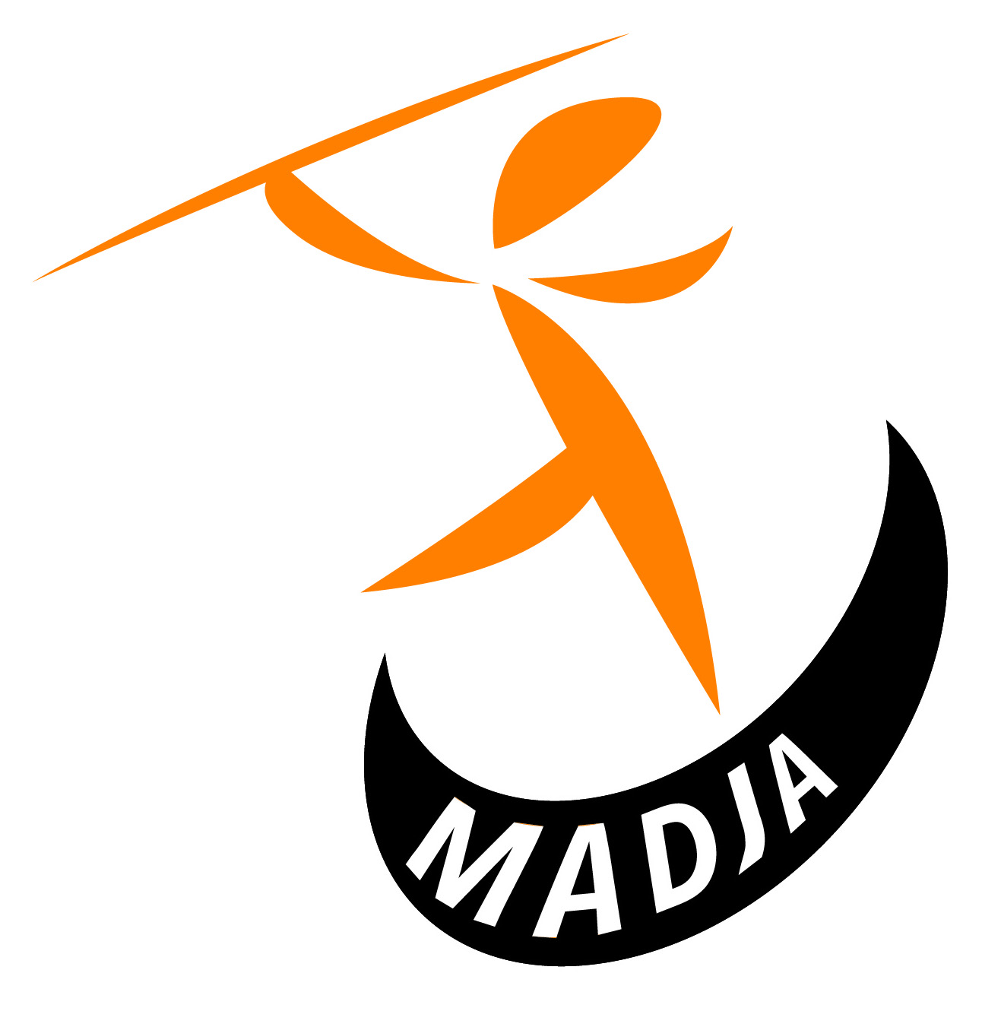
MAD JA 2017 – HOODY ORDER FORM

Name:
Age:
Height:
Chest Size:
 |  | Size | Price | Total
Children’s Size Required: | 7-8 / 9-10 / 11-12 |  | £ 16.00
Youth/Adult Size Required: | S / M / L |  | £ 20.00
1st Line Printing on Back (eg Name): Included in price. |  |  |  | Included  in Price
2nd Line Printing on Back – Optional £1.00 if required:
 | Total:
Cheques should be made payable to MAD JA.
Order Forms with Payment should be handed in at the track or posted to:
MAD JA The New House, brewhouse Hill, Froxfield, Marlbrough, Wiltshire SN8 3LD

